GENERAL BODY SENATE MEETING
FALL SEMESTER
NOVEMBER 29th, 2021

- CALL TO ORDER (7:00pm)

- ROLL CALL

- APPROVAL OF THE AGENDA

- CABINET REPORTS
  - President
    - Good luck on elections
  - Director of Advocacy and Administration
  - Director of Finance
  - Director of Residential Development
    - Aggie points!
  - Director of Residential Outreach and Events
  - Director of Marketing and Promotions
  - National Communications Coordinator
  - NRHH
    - Do OTM
    - Sign up for NRHH
  - IACURH RBD Member

- ADVISOR REPORTS
  - Starting interviews to fill the coordinator position that oversees RLP

- NCC ELECTIONS
  - Declan Andrews
  - Carson Black

Congrats Carson Black

- OPEN FORUM AND GENERAL ANNOUNCEMENTS
  - Bonding event going to grizzly rose
    - Western dance hall thing
  - Mickey is singing next Monday at 6 at the UCA
  - Next meeting is last meeting of the semester
    - No bills just going to be doing an icebreaker type activity
  - VPAF election next Wednesday

- RECOGNITION
  - Rambo
    - Given by Ingwards Hall Council
    - Given to Corbett Hall Council
  - Cam
    - Given by DAA
    - Given to Dani
  - Birthdays
  - Snaps

- ROLL CALL
  - How was your break? Anything to share?
Here is one of my all-time favorite recipes
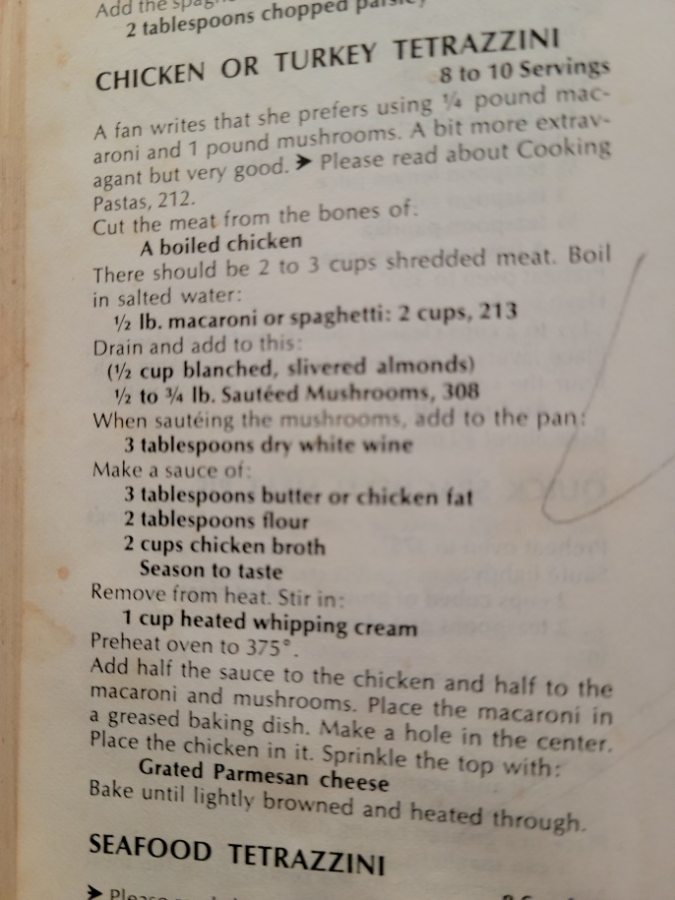
Do not cook this with boiled chicken though, clearly written 40 years ago when you couldn’t just buy a rotisserie chicken for 5 dollars, but best with smoked turkey
ADJOURNMENT

